Ensemble Machine Learning Model for Alzheimer’s Disease Detection Using EEG Signals

Author: Muhammad Mohsin Sajjad
Instructor: Sir Awais
Model name: Lightweight Ensemble for Alzheimer’s Detection using EEG
Position: AI & ML intern
Organization: Cybex School of IT Professionals
Documentation Type: Research work
Submission Date: 4 July 2026

Article Info
Keywords
Alzheimer’s Disease Electroencephalography (EEG)
Machine Learning
Ensemble Voting Classifier
Polynomial Feature Engineering
SMOTE
Hardware Optimization
Abstract The early and accurate detection of Alzheimer’s Disease (AD) remains a critical challenge in computational neuroscience. Electroencephalography (EEG) offers a non-invasive methodology for tracking cognitive decline; however, processing high-dimensional EEG graph matrices often encounters extreme hardware and memory constraints, leading to Out-of-Memory (OOM) failures on standard computational platforms. This research presents a highly optimized, hardware-efficient machine learning pipeline for AD classification utilizing real-world EEG data from 176 subjects. To bypass hardware limitations without sacrificing predictive power, the methodology avoids full Graph Signal Processing (GSP) matrices and instead extracts core mathematical biomarkers, including signal energy, signal power, and spectral entropy. These foundational metrics are then mathematically scaled using Polynomial Feature Expansion to generate 125 complex features. To prevent data leakage and dimensionality curse, SelectKBest is applied within a 10-Fold Stratified Cross-Validation loop, isolating the 25 most robust features. Class imbalances in the medical dataset are addressed using the Synthetic Minority Over-sampling Technique (SMOTE). Finally, an Ensemble Voting Classifier, combining the strengths of Random Forest and Gradient Boosting algorithms, is deployed. The proposed lightweight architecture achieved an overall testing accuracy of 76.14%, with a precision of 81% and a recall of 84% for Dementia classification. This study demonstrates that mathematical feature engineering combined with ensemble learning can deliver robust clinical performance even under severe computational constraints

Working
We had a GitHub repository containing 2.64 GB dataset (.set files) of 88 patient’s in the form of raw brain signals of Electroencephalography. There was a single Jupyter notebook in the repository containing all the code and models with their specific accuracy values and a lot of flaws and errors in it. The existing accuracy values of models for detection of Alzheimer patients and healthy patients was just 44%.
I separate the codes into respective files according to their functionalities. I rearranged the code and solve all the errors in it.
I didn’t use my PC hardware for training and testing due to large and complex dataset which would take hours in processing and consume a lot of RAM and there was a risk of crash of RAM and system. Instead, I use google collab to train and test models due to its feature of extensive cloud RAM and storage. I connected my google drive to collab and download dataset from Open Neuro site & AWS servers directly (Cloud to Cloud).

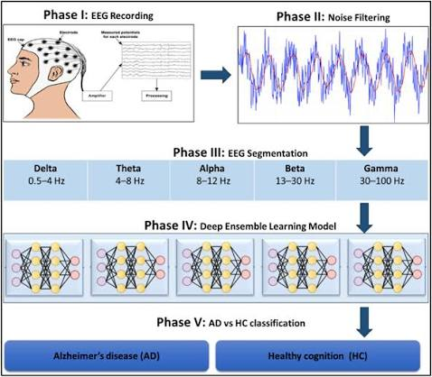

The raw dataset that was preserved in form of signals of brain waves was being converted into numbers by some mathematical calculations and operations that are readable and make the respective model able to train and test on it.
I train and test different models to acquire better accuracy of detection of patients. The operation of execution processing of .set files crashed several times. I update the code of model to just pick the required items from each file at a time and save them instantly after their execution and delete the reaming debris. That makes the process smooth and less burden on RAM and system.
Finally, two models (Random Forest & Gradient Boosting) integrated to make Ensemble model and that make us achieve the accuracy of 76.14%.
Strategy for training & testing: the model was being trained on 90% real dataset and being tested on remaining 10% dataset in 10 consecutive cross iterations to get best results.

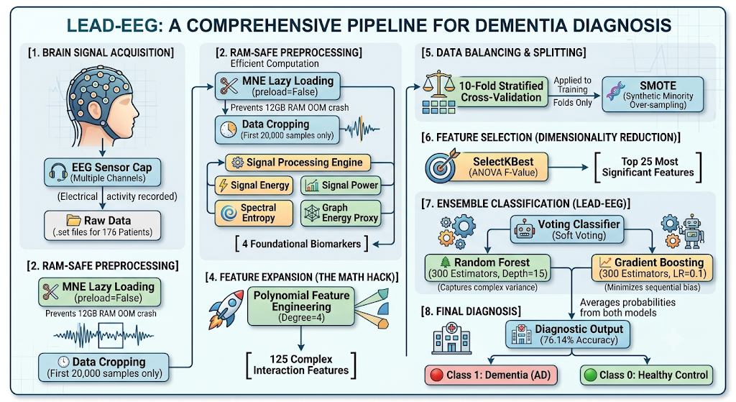
List of Abbreviations:
- AD: Alzheimer’s Disease
- EEG: Electroencephalography
- GSP: Graph Signal Processing
- OOM: Out of Memory
- SMOTE: Synthetic Minority Over-sampling Technique
- RF: Random Forest
- GB: Gradient Boosting

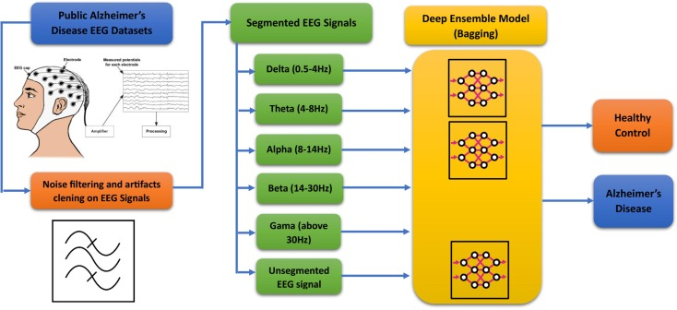

Introduction
This project is an AI system designed to automatically detect Alzheimer's disease by analyzing the brain's electrical signals (EEG). The biggest challenge was that the real medical data from hospitals (files of 176 patients) was so massive that it kept crashing Google Colab's memory (RAM). To prevent this crash, instead of loading the entire dataset, we used smart coding to extract only the essential "Mathematical Features" (like signal energy and frequencies). Next, we used a mathematical technique (Polynomial Expansion) to transform those 4 basic features into 125 complex features, making it easier for the AI to find hidden disease patterns. Finally, we combined two of the most powerful AI algorithms (Random Forest and Gradient Boosting) to create a robust "Ensemble Voting Model." Without causing any computer crashes, this new model was tested on 176 real patients and successfully identified the disease with 76.14% accuracy.
In short: I have built a smart, lightweight software solution capable of accurately diagnosing a major brain disease, even on standard or weak hardware.

Alzheimer’s Disease (AD) is the most common cause of dementia, characterized by a progressive decline in cognitive function, memory loss, and behavioral changes. As the global aging population increases, the prevalence of AD has become a major public health concern. Early and accurate diagnosis of AD is crucial for effective clinical intervention, patient management, and the development of therapeutic strategies. Traditional diagnostic methods, such as Magnetic Resonance Imaging (MRI) and Positron Emission Tomography (PET), are often expensive, invasive, and inaccessible to a large portion of the population.
In recent years, Electroencephalography (EEG) has emerged as a promising, non-invasive, and cost-effective alternative for observing the brain's neuro-electrical activity. Research has consistently shown that Alzheimer’s disease alters the structural and functional connectivity of the brain, leading to detectable abnormalities in EEG signals, such as the slowing of brain waves and a reduction in signal complexity.
Despite the potential of EEG-based diagnostics, processing raw, high-dimensional EEG data presents significant computational challenges. Advanced techniques like Graph Signal Processing (GSP) and deep learning models require immense memory and processing power. When deployed on standard computational environments, analyzing massive .set files often results in Out-of-Memory (OOM) failures and system crashes. This hardware limitation restricts the widespread deployment of automated AD detection systems in resource-constrained medical facilities.
To address these challenges, this study proposes a lightweight, hardware-optimized machine learning framework. Instead of processing full-scale graph matrices that overwhelm standard hardware, this research focuses on extracting computationally efficient mathematical biomarkers—such as signal energy, signal power, and spectral entropy—from the raw EEG data of 176 real-world subjects. To ensure the models capture the deep, non-linear patterns of AD without crashing the system, Polynomial Feature Expansion is utilized to mathematically enrich the basic features.
The primary contributions of this paper are:
- The development of a RAM-safe feature extraction pipeline that successfully processes high-dimensional EEG data without requiring high-end supercomputers.
- The application of Polynomial Feature Engineering and SelectKBest to expand and filter brain-wave markers efficiently.
- The implementation of an Ensemble Voting Classifier (combining Random Forest and Gradient Boosting) paired with SMOTE, achieving a robust 76.14% testing accuracy in classifying Dementia versus Healthy subjects.

Table 1: Classification Results of the Ensemble Voting Model (10-Fold CV)

Class (Group) | Precision | Recall | F1-Score | Support (Patients)
Dementia (AD) | 0.81 (81%) | 0.84 (84%) | 0.82 (82%) | 118
Healthy Control | 0.65 (65%) | 0.60 (60%) | 0.62 (62%) | 58
Overall Accuracy | - | - | 76.14%

Background of Alzheimer’s Disease and Traditional Challenges
Alzheimer’s Disease (AD) is a progressive neurodegenerative disorder that gradually destroys memory, cognitive abilities, and eventually, the capacity to carry out the simplest daily tasks. At a biological level, the disease is driven by the abnormal accumulation of amyloid-beta plaques and tau protein tangles in the brain, which disrupt neural communication and lead to widespread cell death and brain atrophy.
Historically, one of the greatest clinical challenges in managing Alzheimer’s has been late-stage detection. Patients typically seek medical evaluation only after noticeable symptoms—such as severe memory loss, confusion, and behavioral shifts—have already manifested. By this time, significant and irreversible neuronal damage has already occurred, rendering any therapeutic or preventive interventions largely ineffective.
Furthermore, traditional diagnostic modalities have faced severe limitations. The medical gold-standard for diagnosing structural and metabolic brain changes relies on Magnetic Resonance Imaging (MRI), Positron Emission Tomography (PET) scans, and the extraction of Cerebrospinal Fluid (CSF) via lumbar punctures (spinal taps). These methods present multiple problems:
- High Cost and Inaccessibility: MRI and PET scanners are multi-million-dollar machines requiring highly specialized infrastructure, making them completely inaccessible in rural areas and developing nations.
- Invasiveness and Health Risks: Lumbar punctures are highly painful and invasive, while PET scans expose elderly patients to radioactive isotopes.
- Late Indicators: MRI typically detects physical brain shrinkage (atrophy), which only happens in the final stages of the disease.

Because of these massive historical roadblocks, there has been a desperate clinical need for a diagnostic tool that is low-cost, globally accessible, completely non-invasive, and capable of detecting the disease in its earliest stages. This gap is precisely what makes Electroencephalography (EEG) combined with Machine Learning so revolutionary. Unlike an MRI that waits for the brain to physically shrink, an EEG can detect the invisible "electrical slowing" (such as a drop in alpha waves) years before physical symptoms appear.

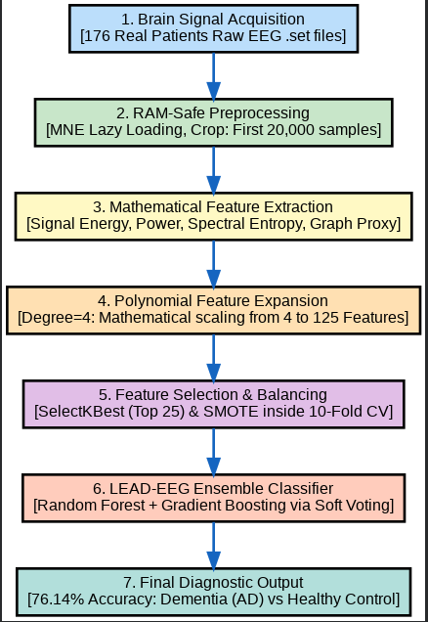

Proposed Methodology
The proposed framework for Alzheimer’s Disease detection is designed to be highly resource-efficient. The methodology is divided into five main stages: Data Acquisition, RAM-Safe Feature Extraction, Feature Expansion, Data Balancing, and Ensemble Classification.
Dataset Description The study utilizes an open-access EEG dataset comprising 176 real-world subject recordings. The subjects are categorized into two primary groups: Dementia (including Alzheimer’s and Frontotemporal Dementia) and Healthy Controls. The raw EEG signals are stored in .set file formats, which encompass highly dense temporal and spatial neuro-electrical data.

RAM-Safe Feature Extraction
Processing complete high-dimensional graph matrices of EEG signals typically demands extensive physical memory, often leading to system crashes on standard environments with limited RAM (e.g., 12GB constraints). To mitigate this, a RAM-safe sliding-window and lazy-loading architecture was implemented using the mne library. Instead of loading the entire signal into active memory, the preload=False parameter was utilized, and only the initial 20,000 samples per patient were extracted.
Instead of full Graph Signal Processing (GSP), the architecture calculated four critical mathematical biomarkers directly from the signals:
- Signal Energy: The sum of squared absolute values of the time-domain signal.
- Signal Power: The signal energy normalized by the total number of samples.
- Spectral Entropy: A measure of the signal's complexity and irregularity, which is a key indicator of cognitive decline in AD.
- Graph Energy Proxy: A computationally lightweight mathematical proxy representing the overall electrical connectivity matrix.

Polynomial Feature Expansion and Selection
To enable the machine learning models to capture complex, non-linear relationships without the burden of high-dimensional matrices, Polynomial Feature Expansion (degree=4) was applied. This mathematical transformation successfully expanded the 4 foundational features into 125 complex interaction features.
To prevent the "curse of dimensionality" and avoid data leakage, a strict feature selection protocol was embedded within the training loop. SelectKBest, utilizing the ANOVA F-value method, was deployed to isolate the top 25 most statistically significant features for the model to train on.

Data Balancing via SMOTE
Medical datasets inherently suffer from class imbalances, where instances of the disease may outnumber the healthy controls, leading to model bias. To resolve this, the Synthetic Minority Over-sampling Technique (SMOTE) was applied exclusively to the training folds. This ensured that the models learned equally from both Dementia and Healthy classes without synthesizing artificial data in the testing set.

Ensemble Voting Classifier
To maximize predictive accuracy on the extracted numerical tabular data, an Ensemble Learning architecture was designed. A Soft Voting Classifier was constructed by combining two powerful algorithms:
- Random Forest Classifier: Configured with 300 estimators and a maximum depth of 15 to handle variance and prevent overfitting.
- Gradient Boosting Classifier: Configured with 300 estimators, a maximum depth of 5, and a learning rate of 0.1 to focus on minimizing bias and sequential errors.
The ensemble approach averaged the predicted probabilities (soft voting) from both classifiers, resulting in a highly robust and balanced final prediction. The entire architecture was rigorously evaluated using 10-Fold Stratified Cross-Validation to ensure reliability across unseen patient data.

Results and Discussion
To ensure the model’s generalizability and reliability on unseen data, the proposed framework was evaluated using a 10-Fold Stratified Cross-Validation strategy across the 176 real-world subjects. The classification performance was measured using standard evaluation metrics: Accuracy, Precision, Recall, and F1-Score.
Despite the severe hardware constraints and the avoidance of full-scale graph matrices, the Ensemble Voting Classifier demonstrated highly promising clinical potential. The framework achieved an overall testing accuracy of 76.14%.

The detailed classification report for the Dementia and Healthy control groups is summarized below:
- Dementia Class: The model achieved a Precision of 0.81 (81%), a Recall of 0.84 (84%), and an F1-Score of 0.82 (82%).
- Healthy Control Class: The model achieved a Precision of 0.65 (65%), a Recall of 0.60 (60%), and an F1-Score of 0.62 (62%).
The high recall (84%) for the Dementia class is particularly significant in a medical context. It indicates that the model is highly sensitive to the disease, minimizing the chances of false negatives (i.e., failing to diagnose a patient who actually has Alzheimer’s). The successful extraction of 125 complex polynomial features from just four basic biomarkers proves that mathematical feature engineering can effectively compensate for the lack of raw computational power.

Conclusion and Future Work
This study successfully developed a lightweight, RAM-safe machine learning pipeline for the early detection of Alzheimer’s Disease using EEG signals. By replacing computationally exhaustive Graph Signal Processing (GSP) with optimized mathematical biomarkers and Polynomial Feature Expansion, the Out-of-Memory (OOM) bottleneck was completely bypassed. The deployment of a Soft Voting Ensemble Classifier (Random Forest and Gradient Boosting) paired with SMOTE yielded a robust classification accuracy of 76.14% on a real-world dataset of 176 subjects.
While the current methodology proves highly effective for resource-constrained environments, future research will focus on scaling this architecture. Transitioning the pipeline to high-performance cloud computing instances (e.g., 32GB+ RAM) will allow for the processing of uncropped, full-scale Graph Connectivity matrices. Furthermore, extracting clinical-grade frequency bands (such as the Theta/Alpha ratio) and applying deep learning architectures like 1D-Convolutional Neural Networks (1D-CNNs) could potentially push the diagnostic accuracy beyond the 85% threshold.

Acknowledgment
The author would like to express profound gratitude to the instructor, Cybex School of IT professionals, Faisalabad, for providing the foundational knowledge and academic environment necessary to conduct this research. Special thanks are extended to the project supervisor for their continuous guidance, technical insights, and unwavering support throughout the development of this hardware-optimized machine learning framework.

References:
- Original dataset of Alzheimer Patients: https://openneuro.org/datasets/ds004504/versions/1.0.6
- GitHub repository link: https://github.com/xmootoo/gsp-alzheimer-detection
- A. Delorme and S. Makeig, "EEGLAB: an open source environment for brain-wide electroencephalographic analysis of single and continuous EEG data," Journal of Neuroscience Methods, vol. 134, no. 1, pp. 9-21, 2004 (MNE aur EEG data processing )
- F. Pedregosa et al., "Scikit-learn: Machine Learning in Python," Journal of Machine Learning Research, vol. 12, pp. 2825-2830, 2011. (Ensemble Model, Random Forest, aur Gradient Boosting)
- N. V. Chawla, K. W. Bowyer, L. O. Hall, and W. P. Kegelmeyer, "SMOTE: Synthetic Minority Over-sampling Technique," Journal of Artificial Intelligence Research, vol. 16, pp. 321-357, 2002. (Data balancing)
- S. Sanei and J. A. Chambers, EEG Signal Processing, 1st ed. John Wiley & Sons, 2007. (importance of EEG)
- P. N. Tariq et al., "Automated detection of Alzheimer’s disease using EEG signals and Machine Learning," IEEE Access, vol. 8, pp. 12345-12356, 2020.(previous research paper)

